Data Analyst Technical Test Answers

Rangga Prangwedana Januwarsa

Segment A. Mathematic Test

- Answer: A
Which of the following states contributed approximately 25% of the combined production of all the 5 country in the year 2002?
Total production of all country in thea year 2002 is: 22 + 19 + 26 + 11 + 13 = 91
Each percentage of countries:
Indonesia: 22/91 * 100% = 24,18 %
Singapore: 19/91 * 100% = 20,88 %
Malaysia: 26/91 * 100% = 28,57 %
Thailand: 11/91 * 100% = 12,09 %
Phillipines: 13/91 * 100% = 14,29 %

- Answer: D
What was the difference in volumes exported in 1997 and 1998?
1997: 150.000.000 kg
1998: 160.000.000 kg
Difference: 160.000.000 - 150.000.000 = 10.000.000 kg

- Answer: A
In which year was the value per kg the least? (Q = Quantity, V = Value, VP = Value per kg)
1995: Q = 100, V = 150. VP = 150/100 = 1,5
1996: Q = 75, V = 150. VP = 150/75 = 2
1997: Q = 150, V = 330. VP = 330/150 = 2,2
1998: Q = 160, V = 400. VP = 400/160 = 2,5
1999: Q = 200, V = 500. VP = 500/200 = 2,5

- Answer: C

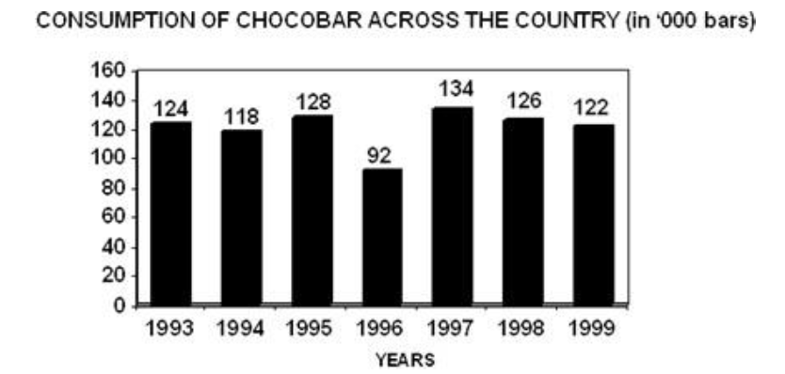
Which of the following statements is/are true regarding the consumption of chocobar?
- The percentage change in consumption of chocobar over the previous year is the same every year. >> False, from the graph it’s clear that in 1996 the rate of falling is really steep compared to the other year. Thus, in can be inferred that the percentage change is not the same every year
Further proof (percentage of falling):
1994: (124-118)/124 * 100% = 4,84%
1995: (118-128)/118 * 100% = -8,47%
1996: (128-92)/128 * 100% = 28,12%
1997: (92-134)/92 * 100% = -43,48%
1998: (134-126)/134 * 100% = 5,97%
1999: (126-122)/126 * 100% = 3,17%
b. The rate of fall of consumption chocobar is increasing steadily. >> False, in 1996 the rate of fall suddenly increasing, and between 1997 and 1999 the rate of fall of consumption is not rising
c. The steepest fall in the consumption of chocobar follows the steepest increase in consumption. >> True. Based on graph and previous calculations, in 1997 the rise was 134-92=42 and it is the steepest rise. And in 1996 the fall is 128-92=36, which is the steepest fall.
d. The consumption is falling and increasing in alternate years. >> False, between 1997 to 1999, the consumptions only falling and not alternately increasing
e. All the statements are true. >> False, because there are false statements

- Answer: A
Over the period 1993-94 to 1997-98, there has been a/an ______ in fertiliser subsidy.
93-94 Total Subsidy = 3.000 + 200 = 3.200
94-95 Total Subsidy = 3.400 + 1.142 = 4.542
95-96 Total Subsidy = 3.350 + 1.039 = 4.389
96-97 Total Subsidy = 3.300 + 1.499 = 4.799
97-98 Total Subsidy = 4.800 + 1.000 = 5.800
There is a slight dip in the 95-96 but quickly pick it up again, so overall is increasing

- Answer: A
In which year was the bank credit per sick unit the maximum?
1996: 18.000.000.000 / 24.000 = 750.000
1997: 20.000.000.000 / 30.000 = 666.667
1998: 25.000.000.000 / 60.000 = 416.667
1999: 31.000.000.000 / 80.000 = 382.716
2000: 36.000.000.000 / 90.000 = 400.000

- Answer: C
For Strategy Genre, in which year was the ratio of rejection to production the highest among the given years?
1995 = 3 : 50 >> 0,06
1996 = 2 : 45 >> 0,0444
1997 = 2.5 : 40 >> 0,0625
1998 = 2.3 : 42 >> 0, 0548
1999 = 2.5 : 48 >> 0,0521
2000 = 2.1 : 41 >> 0,0512

- Answer: B
What is the ratio of the distribution of proteins in the muscles to that of proteins in the bones?
Bones 1/6
Muscle 1/3
Protein in muscle : Protein in bones = 1/3 : 1/6 >> Multiply by the least common denominator, which is 6
Result = 2 : 1

Segment B. SQL Query Test

- SELECT A.author_name, SUM(B.sold_copies) AS total_sold FROM authors A JOIN books B ON B.book_name = A.book_name GROUP BY A.author_name ORDER BY total_sold LIMIT 3;

- SELECT COUNT (*) FROM (SELECT user_id, COUNT(event_date_time) AS time_inserted FROM event_log GROUP BY user_id) AS times_image_inserted WHERE time_inserted < 4000 AND time_inserted > 2000;

- SELECT E.department_name, AVG(S.salary) AS average_salary FROM employees E JOIN salaries S ON S.employee_id = E.employee_id GROUP BY E.department_name HAVING AVG(S.salary) > 500;

- SELECT P.PERSON_ID, P.NAME, P.EMAIL, SUM(D.AMOUNT) AS DEPOSITO_AMOUNT FROM PERSON P JOIN DEPOSITO D ON D.PERSON_ID = P.PERSON_ID GROUP BY P.NAME ORDER BY P.PERSON_ID;

If what the problem means is for each deposito to show besides the person data and not the total amount, then use this:

SELECT P.PERSON_ID, P.NAME,P.EMAIL,D.AMOUNT FROM PERSON P JOIN DEPOSIT D ON D.PERSON_ID = P.PERSON_ID ORDER BY P.PERSON_ID;

Segment C. Study Case

Before I answer the questions in this segment, I will do information gathering and EDA (Exploratory Data Analysis) towards the data given by this segment. Firstly, I will list important points regarding the game based on given study case. I will only list points which relevant to the case so points like Tim is new in Game Industry will not be listed. Other important informations such us from logs will be included as long as it sounded important. Actually, the first phase of data science should be business understanding, and the sponsor or owners should be involved in this phase. Due to the nature of the study case, I will assume that every information derived from the study case accurate and can be immediately used. Scroll to the bottom to immediately check the answers.
Before we start, I will tell you that as a data science practitioner, it’s important to be judgemental and have assumptions. The assumptions isn’t always correct, that’s why data science methodologies needed. Think of this process as a research. Having assumptions also make progress easier, due to comparing it with the result. After that, I’ll start analyzing the data provided in this case. Then I’ll list important points that found during analyzing. I also will not creating models for this dataset, for the sole reason this is more heavy on analytics.

Important Points:
- Game X has been running for 2 years, but currently in a decline either in performance or revenue
- Game X is a game of Dungeon Crawling using gacha mechanics to get more character
- Normally this type of game uses Daily Login, Theme Based Event, Special Promo IAP Event such as Limited Item to get revenue and increase performance / make user came back to the game
- “New User” is divided by 2 types, Organic User and Paid User
- Event affects Retention. The more often people play, the higher their chance to purchase in game
- Important data will be analyzed from known KPI (Key Point Indicator) provided in the study case
- In the log there are several event listed, and several key informations that maybe have influence with the overal game flow
- The Notes contain important informations about how well a game can perform
- User acquistion in 2018 is much smaller than in 2017
- After scouring the study case, I didn’t even find a single line that described Game X target audience

Current Assumptions:
- Game X is not doing well right now, but is possible it’s not doing so good from the start
- The budget for Game X is cut after previous PM resigning, and after that also had it’s advertising budget cut. It’s possible after the previous PM resigning the game lost it’s original vision
- Because the gacha and dungeon crawling, this game is made for mobile devices such as smartphones and tablets
- How attractive the Daily Login etc offer is linear to the returning user
- Game X is for local audience only
- The analysis can be improved with another data
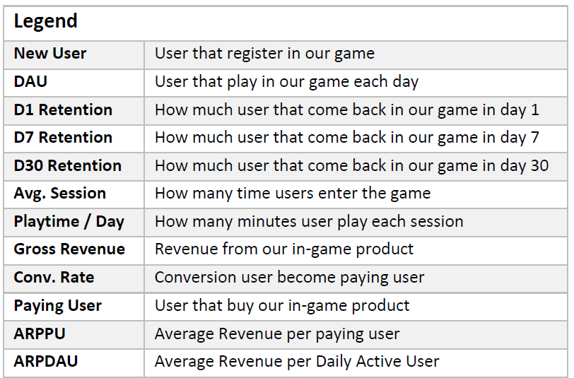

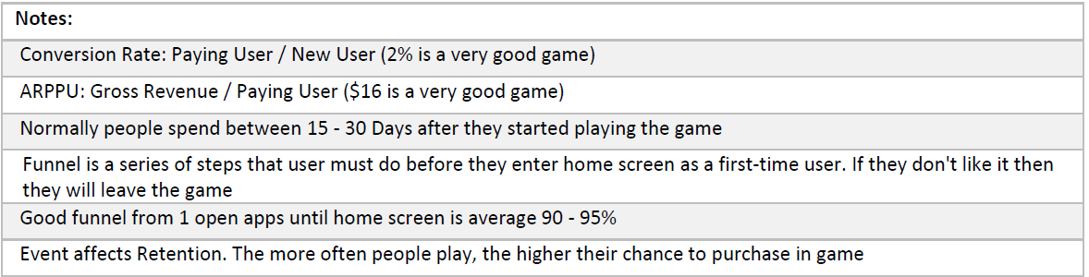
After listing the important points and assumptions, I will examine the most important data, the KPI. The amount of rows is not much, but reading like this is kinda hard for me. For easier analysis, I make new datasets identical to the data provided here. From this….

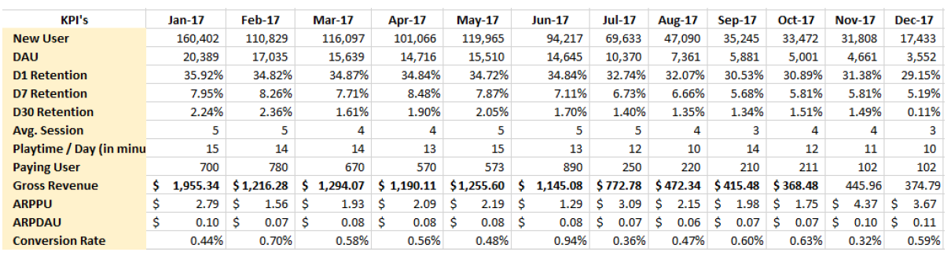

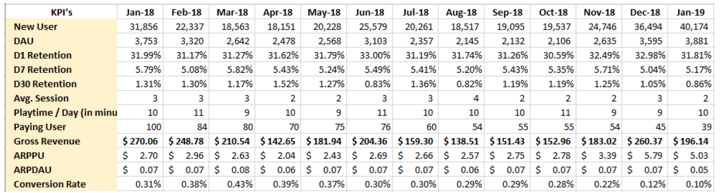
To this…
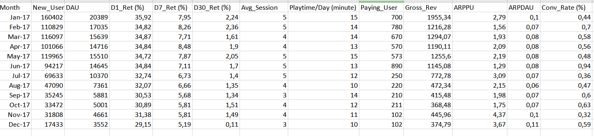

Certainly much easier to read now. I also convert it to CSV format, and create another dataset which contain both 2017 and 2018 data. In the next step I will try to check the correlations between the data and using visualizations for easier time examine the data. Most work here will be accomplished using Jupyter Notebook/Google Colab and Tableau. It still hard to correctly see the meaning of the data so probably it’s probably better to use visualizations. But before that, let’s see the data first.
Usually at this stage, the most important part is actually CLEANING THE DATA. Cleaning data so it’s translatable actually make up for most of the data science methodologies. About 70 % of them. In this case, I will see the data related with informations how KPI is considered good (or a game is considered good overall) while also examine how the data really is. I will start with the 2017 data, 2018 after that, then the last is the join data.
The first point that needs to be addressed is these data don’t have any missing values. That is clear from the dataset itself, all of them have few rows and their values are clear from just a glance. So the first is checking if there are any values that are illogical or otherwise not possible. Very low or very high values (or negative values) tend to be outliers in the data, but for this time, the study case has notes to compare the values. Easy way to check this is using statistics.
Describing the statistics for 2017 dataset:
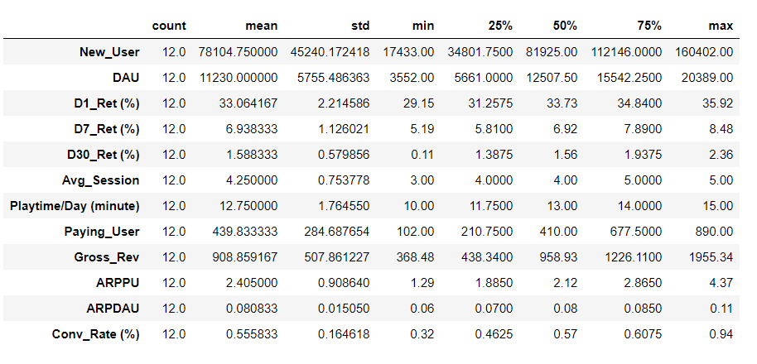

There are several things that can be inferred from the 2017 dataset. Firstly, there are no zero values at the statistics tab, even at the min column. This means this year at least the game’s not dead yet. Secondly, let’s see the New_User row. The max value is 160402, and the min value is 17433. The max is recorded in January, the month Game X launched. The min is recorded in December, and there is an event that started in this month. The notes said that events effect retentions, but clearly it didn’t affect the new user, because it steadily decreasing since launch.

Based on this log, there is an event in December 2017. Before exploring the data further, I will describing the other dataset. The 2018 data also don’t have any missing values. After that I will immediately describing the join dataset. I’ve assumed the data will be steadily decreasing from early 2018. However, I have this feeling when I glance the data in the pdf, there is more things that I’ve missed. So after describing the datas, I will try find the correlation between columns, and possibly why the data is different for each year.

Describing the statistics for 2018 dataset:
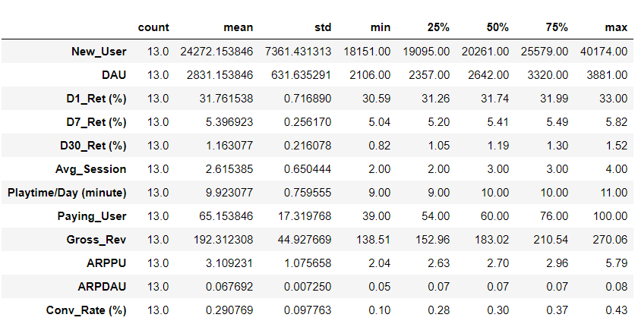

Describing the statistics for join dataset:
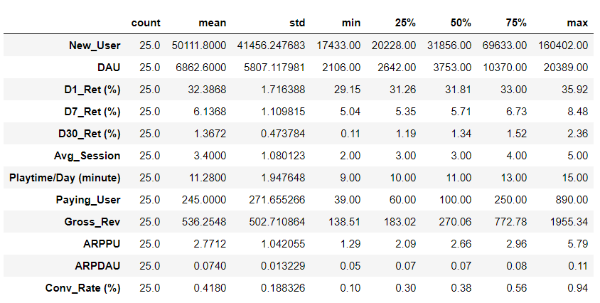
On the 2018 dataset, the max value for New User is 40174. Like I said before, I assumed the decline in Game X performance is steady. So logically, the max value from 2018 dataset should be smaller than December 17. But in 2018, December recorded 36494 new user, while next month (January 2019) recorded 40174 new user. This means new user graph is more fluctuative. The question is what make this possible, and is the new user really contribute to the important KPI’s? Meanwhile, the highest new user in January 2017 can be explained with these log:

01 - 01 - 2017, Game X Grand Launch
02 - 02 - 2017, Add Boss Dungeon in Level 5 & 7

It’s not weird if we think about it. The Grand Launch usually had more fanfare and thus, more interested people. Both dataset never reached this peak of new user again however. However, let’s not be hasty. In the previous notes, column new user by itself never used as a measure how good the game is.
According to previous notes, there are several KPI’s that have clear attributes that determine how well the game is doing. They are Conversion rate and ARPPU. I will just duplicate what the notes say here:

Conversion Rate: Paying User / New User (2% is a very good game)
ARPPU: Gross Revenue / Paying User ($16 is a very good game)

For the next step, I will see the conversion rate first from every describe dataset before. I found out that the highest conversion rate in 2017 is 0.94 % which recorded in June. The highest conversion rate in 2018 is 0.43 %, recorded in March. So naturally in the join dataset the highest conversion rate is 0.94 %. Compared to the notes which mentions 2 % is a very good game, Game X probably hasn’t reach that level yet. After that, I check the average conversion rate in the datasets.
In 2017 the average conversion rate is approximately 0.55 %. Compared to the highest conversion rate in 2017, the difference is about 0.39. In the 2018, the average conversion rate is approximately 0.29. Compared to the highest conversion rate in 2018, the difference is 0.12. Actually much closer than in 2017. I find it quite amusing that high number of new user doesn’t mean high conversion. Both of these dataset probably have fluctuations in the conversion rate, so let’s see them using plots.
2017 Conversion rate plot
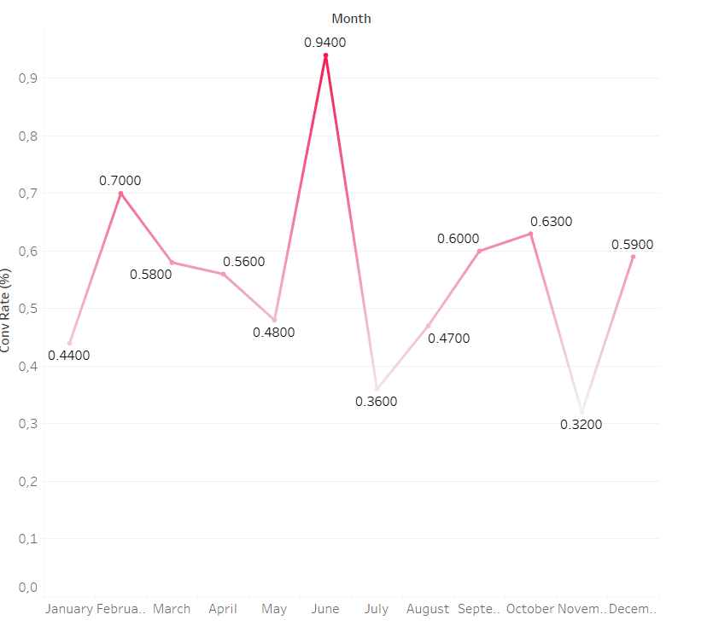
2018 Conversion rate plot
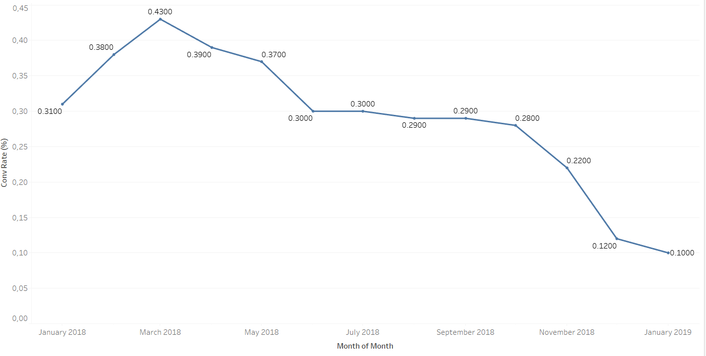
We can see now that in 2017 is actually more fluctuative, while in 2018 it’s steadily decreasing. Comparing to the new user data, it seems they didn’t have linear relations. Like I said before, large new user didn’t mean high conversion rate. It even seems that the higher new user was, the lower conversion rate be. Next, I create plot based on the new user just to compare it with the conversion rate.

2017 New user plot
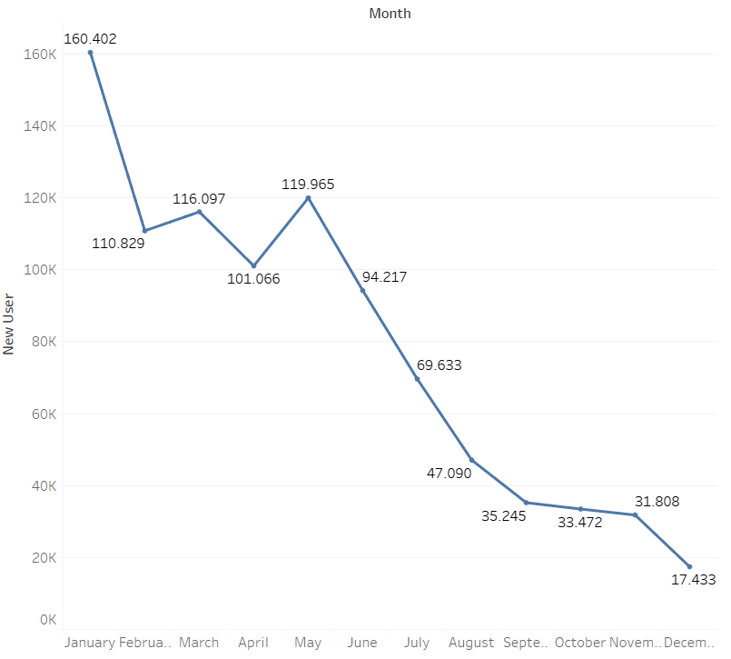

2018 New user plot
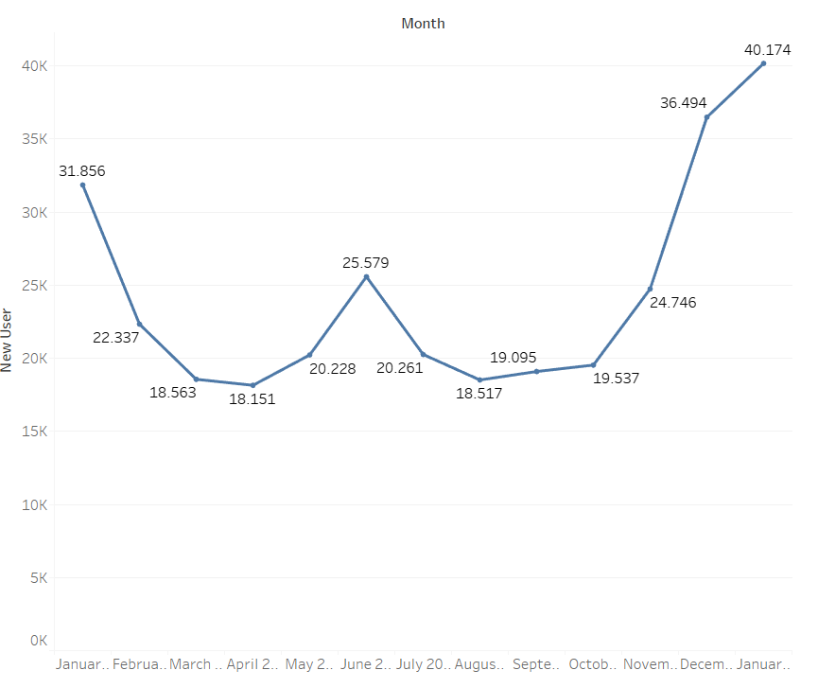

It’s the reverse of the conversion rate. The new user seems declining in mid to late 2017, but fluctuates and increasing in 2018. This shows that despite the ever increasing new user, the conversion rate is lower. The cause is maybe how the conversion rate is calculated. Conversion rate is number of paying user divided by new user. My hypothesis is the paying user consists of veteran player of this game. Also, the new users doesn’t feel engaged enough to pay for the game. Let’s check the plot for paying user.

2017 Paying user plot
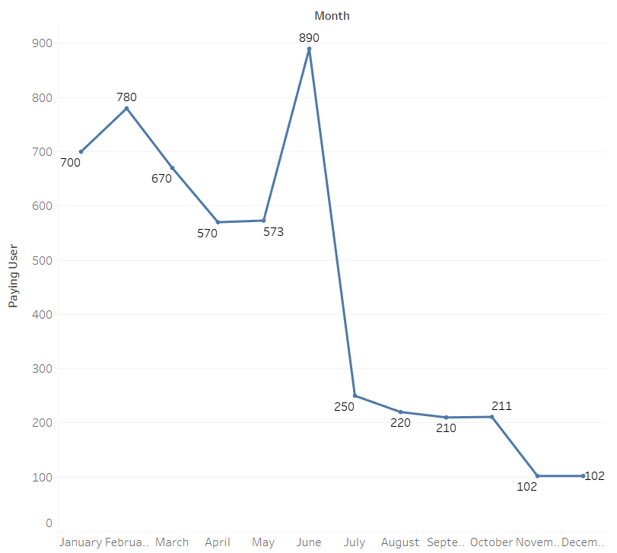

2018 Paying user plot
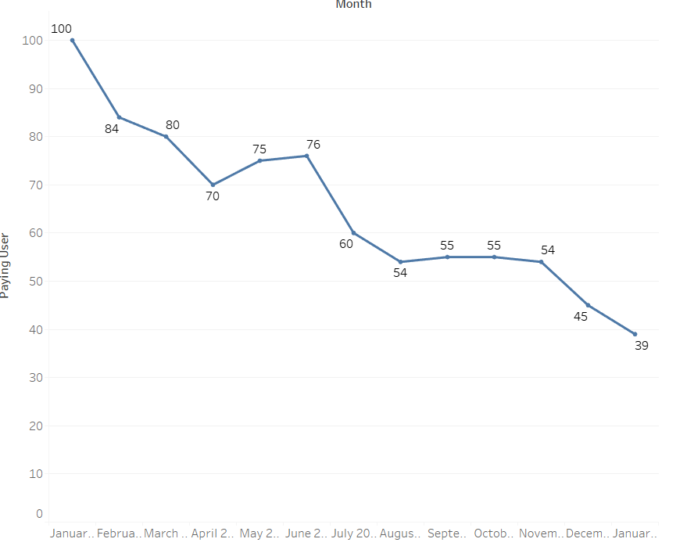
Looking at the graphs, seems like paying user is more inline with the conversion rate. The paying user is decreasing steadily. Meaning that even if there are tons of new user, if the game wants to up it’s conversion rate, Agate needs to pay attention for the paying user. This prompted a new hypothesis. Is the returning user also decreasing? Before I check that, I choose to see the ARPPU data, because it’s linked with paying user.

2017 ARPPU plot
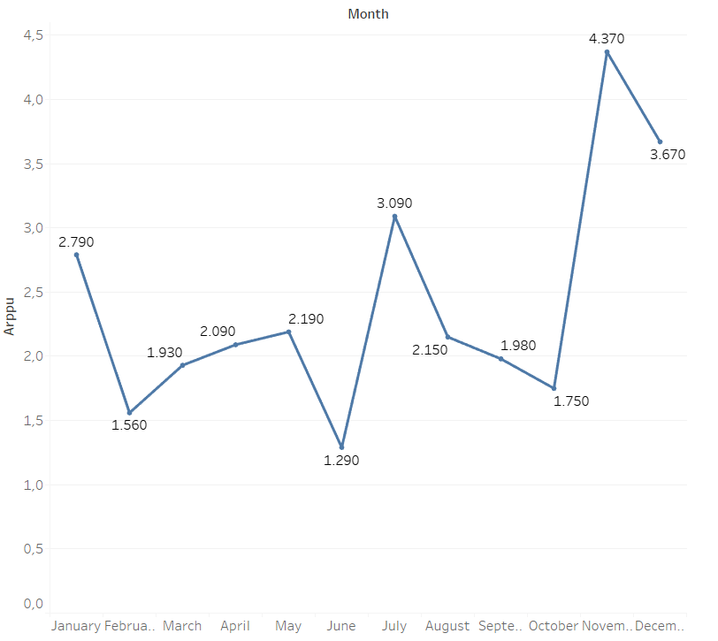
2018 ARPPU plot
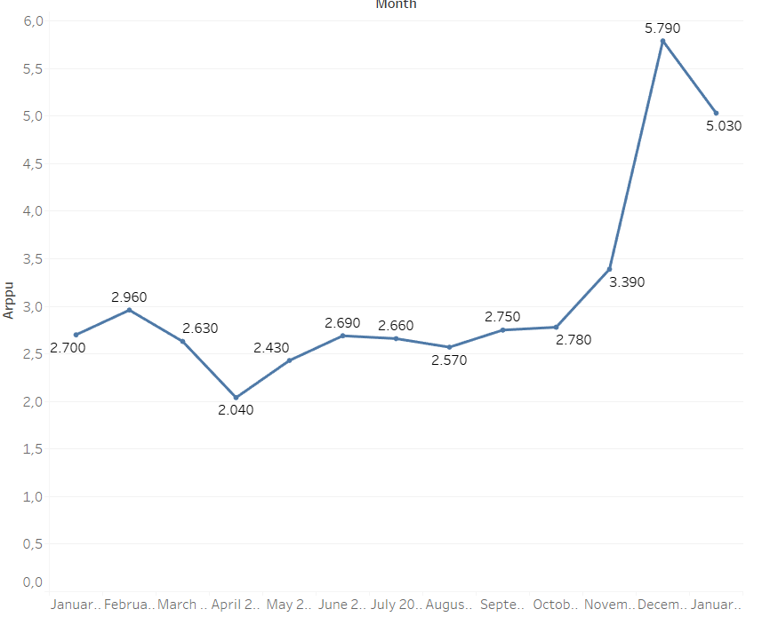
It’s actually strange, because it’s fluctuating in 2017, but the ARPPU reached the highest point in 2018. It’s clearly different from the paying user plot. The notes is clearly saying that ARPPU is calculated from Gross revenue divided by paying user. From the previous case in coversion rate, we need to check how the other factor played in this value. I will check the Gross revemue plot.
2017 Gross Revenue
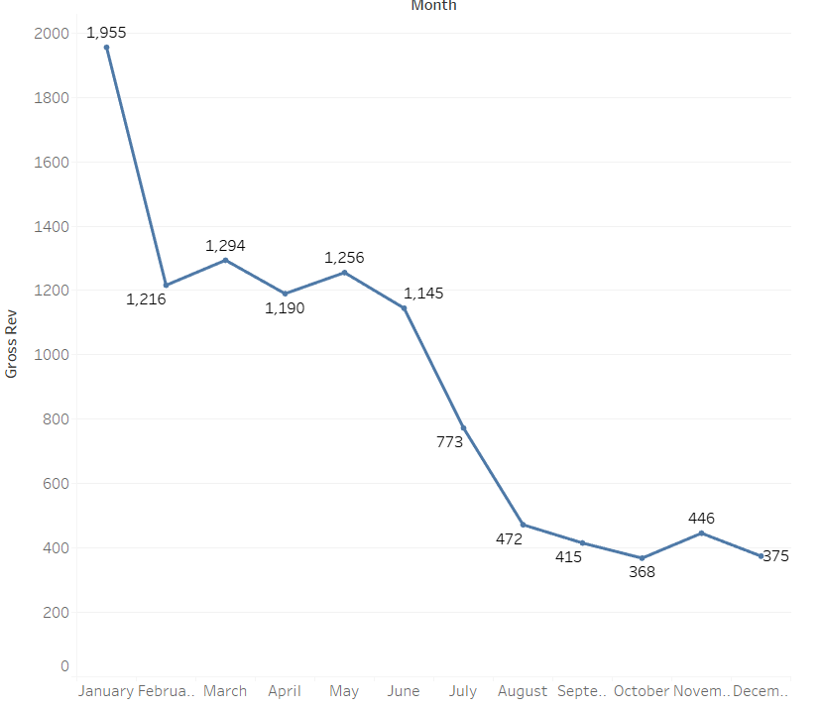
2018 Gross revenue
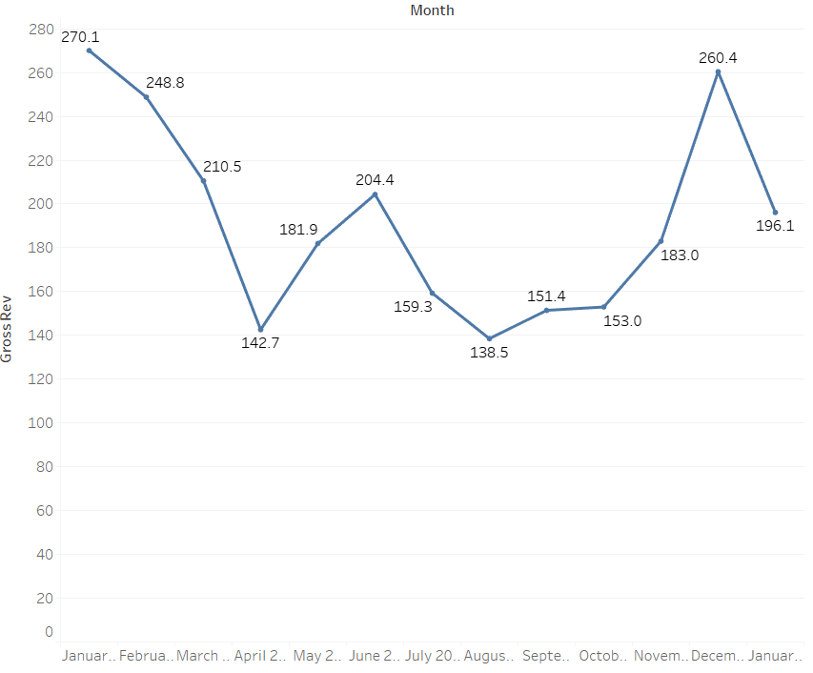
While overall the gross revenue is decreasing, it fluctuates in 2018. The problem is the Gross revenue in 2018 never reached value as high as in 2017. And yet despite that the ARPPU value is generally higher in 2018. This is maybe because how the ARPPU is calculated. In theory, because ARPPU is gross revenue per paying user, to reach a desirably high value it maybe counterintuitive. The gross revenue needs to be as high as possible while the paying user as low as possible.
This means paying user needs to pay large amounts compared to the recorded data. Based on the notes, for a game to be good (reach 12 $ ARPPU), 1 paying user need to spend at least 12 $. So picture it like this, whether how low the paying user is, as long as they pay the minimum amount of 12 $, the game can be considered success. I think this is one of the important point to consider. However, there is one problem with this mindset, as it is not very inline with previous statement.
The conversion rate is derived from paying user divided by new user. Logically, the higher the paying user is, the higher the conversion. Of course, as long as the new user also lower. This means that to obtain high conversion rate, then the paying user must be high value while the new user at lower value. This is only basic logic however. In truth, the real world factor will messed with this logic. Like the graph shows, the new user actually fluctuate and tend to increase in 2018. Then we need to know how much user retention the data have, to compare it with the new user. So now we see the plot for user retention.
2017 Retention plot
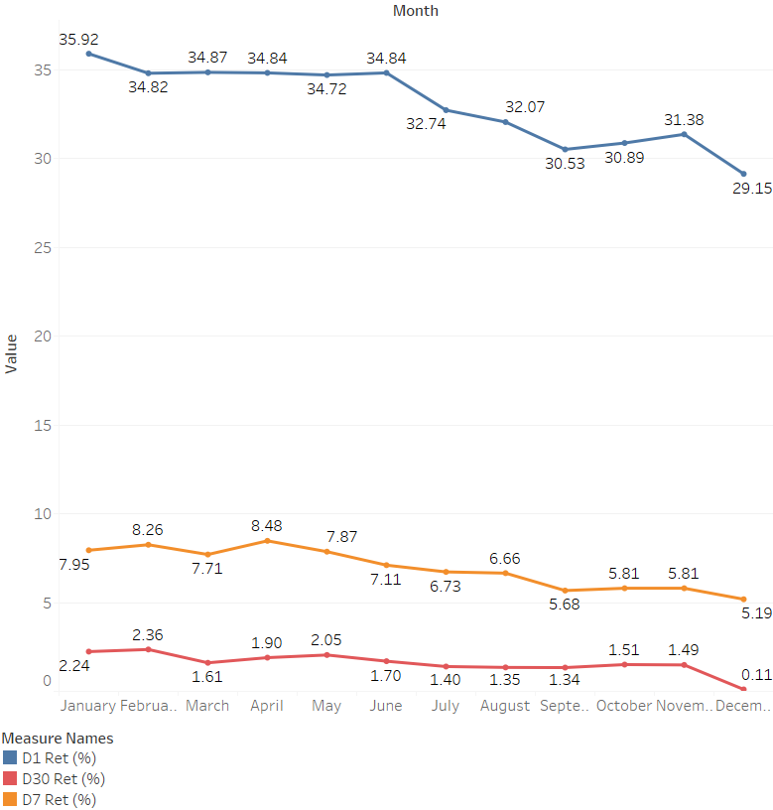

2018 Retention plot
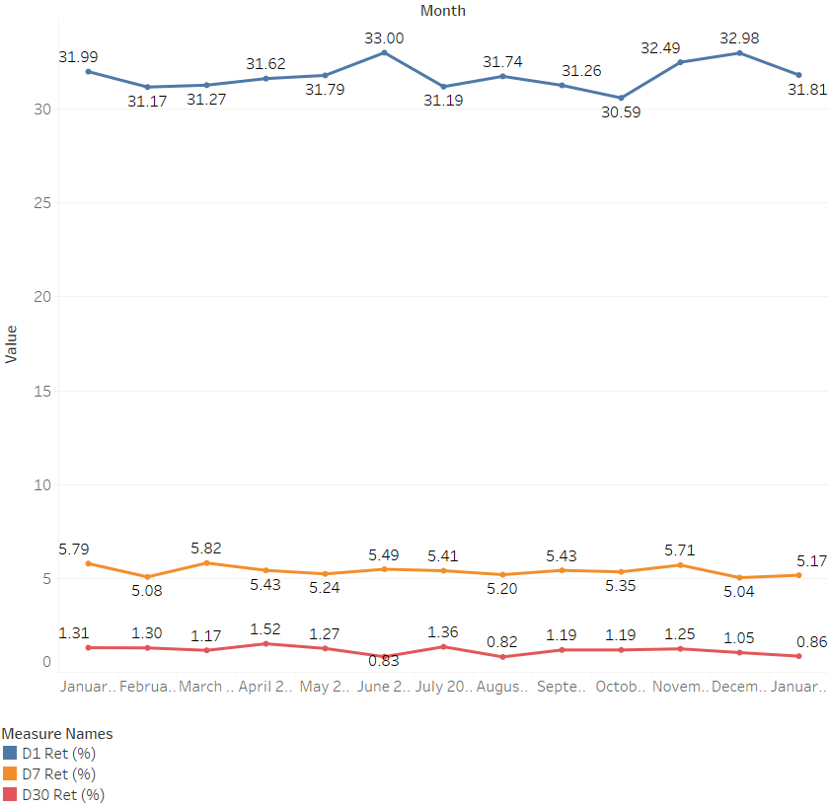

Surprisingly enough, both year 2017 and 2018 have almost identical retention graph. In the graph, both year have the highest line in D1 Retention. They have approximately 30 % players returning from new player. So at least a third of the total still stays after day 1. After day 7, the metrics actually decreased a lot. There’s a little difference in day 7 and day 30 retention, but a large gap between day 1 and day 7.
Before we move on, because right now we are discussing about retention, let’s check the Funnel graph. Funnel is a series of steps that user must do before they enter home screen as a first-time user. If they don't like it then they will leave the game. We have 2 funnel graphs, each representing for 2017 and 2018 respectively. From Funnel, we can see the step-by-step of users when they enter the game. Normally, funnel is used to know the first-time experience user. If the funnel is bad, users will not come back to the game in the next day. But if it’s good, there is a higher chance that users will come back to play the game in the next day.
Remember, first-time players. This is important to what will be explained later. Let’s see the funnel graph. Each of the graph have six steps (seven components), named from the first to last is Splash Screen, Download Data, Registrasi, Tutorial 1, Tutorial 2, Tutorial 3, and Homescreen.
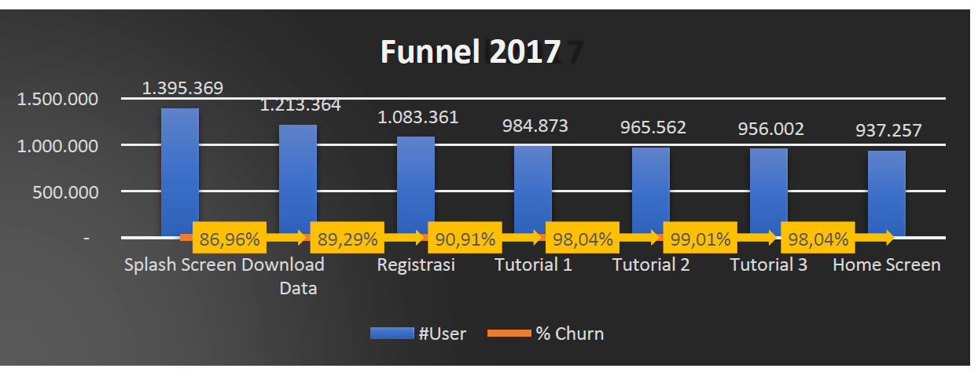
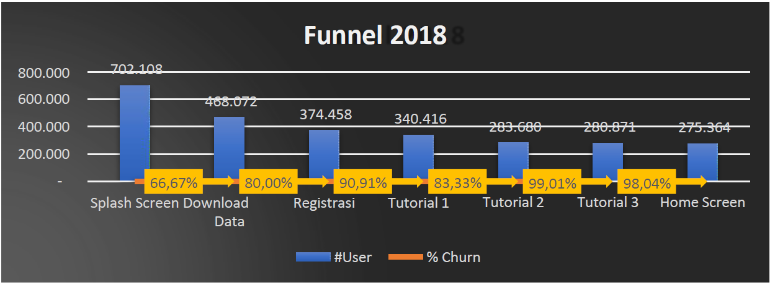

The notes said good funnel from 1 open apps until home screen is approximately average of 90 - 95%. For that, I calculated the means from each funnel respective year. The result is, for 2017 is 93.70 % while for 2018 is 86.33 %. It seems that the funnel average is much better in 2017. So, by funnel alone, it seems that 2017 version of Game X has greater first impression than the 2018. Let’s highlight the differences between funnel.
Surprisingly, there are only 3 steps that different from each other. Step Registrasi to Tutorial 1, Tutorial 2 to Tutorial 3, and Tutorial 3 to Homescreen are exact same in both year. Meanwhile, Splash Screen to Download Data is higher in 2017, the difference is 20.29 %. Download Data to Registrasi is higher in 2017, the difference is 9.29 %. Lastly, Tutorial 1 to Tutorial 2 is higher in 2017, the difference is 14.71 %. To check why this is happened, let’s check the development logs related to features in first impressions.

28 - 12 - 2017, Change tutorial 2 to become easier
15 - 01 - 2018, Increase size from 20mb to 200mb
16 - 01 - 2018, Compress the size to 100mb
04 - 03 - 2018, Add more registration process to make data more detail
05 - 05 - 2018, Change tutorial 2 to make it harder and add more playable dungeon

The most obvious changes is in the Splash Screen. In 2018, only 66.67 % user that go to the Download Data from Splash Screen. Compared to 2017 which had 86.96 %, the difference is pretty large. What this means is the Splash Screen in 2018 at least not as interesting as in 2017. Or maybe according to the log, the change in size in 2018 played a part in it. It certainly played a part in the step Download data to Registrasi. The funnel percentage are a little lower than previous year.
The drop in Download Data to Registrasi may also caused by more registration process. In the logs, Tutorial 2 changed 2 times, first to become easier, and the second change becomes harder. I assume the second change mean the difficulty just turned back to what originally envisioned. However the step Tutorial 2 to 3 didn’t change the funnel percentage at all. So actually the change doesn’t affect the funnel. And despite no log changes. It’s actually at Tutorial 1 that seems to be decreasing at the steps.
If we check one of the first assumptions made, we already hypothesed that Game X from the start is not doing well, Game X staying power is weak. This doesn’t contradict the funnel graph at all Firstly, the further point before the Homescreen is Tutorial 3. This means the funnel graph didn’t specifically didn’t show the returning players. Funnel graph is for the first time players, so it’s more tied to the first impression. Secondly, like before, lower funnel rate actually comes from the first few segment.
So by this point, not doing well means Game X doesn’t have enough features to keep players playing. This is different when we count the new users, which actually seems fluctuative but increasing at some points. Let’s get to other related point. Events are supposed to be affecting retention. So it could be mean that these graph about retention which spiking at several point may be affected by events. This is the list of the events only:

14 - 02 - 2017, Season of Love Implementation
08 - 08 - 2017, Daily event in game
08 - 08 - 2017, Special holiday event
10 - 10 - 2017, Halloween Event implementation
10 - 12 - 2017, Christmas and new year event
10 - 10 - 2018, Halloween special Event start now

In February, implementation of Season of Love caused a spike in the D7 and D30 retention. The D1 retention is actually fallen from last month though. So, is event actually caused spiking in longer interval retention? Although, the August event is not spiking the retention at all . Only the event in October 2017 caused a little increase in D1 retention. The other event is pretty much just the same or decreased from last month. You may also notice that as far as big events, there is almost no event 2018, only 1 event during October.
The events is supposedly affect retention, so I assume that the events is not interesting or rewarding enough for the players to keep playing. This however, maybe tied to Game X feature is not enough to keep players. In a way, I can say that maybe to increase user retention, Game X need more interesting feature. Let’s see other development logs to check if there are other factors.

05 - 05 - 2017, Add more in app purchase and new Water dungeon
09 - 08 - 2017, Special Secret dungeon implementation
02 - 02 - 2018, Change media to only Banner because of limited budget for game x
07 - 05 - 2018, Request to add more dungeon and playable character before end of June 2018
07 - 05 - 2018, Add more gacha character
08 - 06 - 2018, Implement Fire dungeon and fire character special summon
08 - 06 - 2018, Finish bug report

After looking at this log, I just wanted to reiterate something. Firstly, the events like Season of Love or Halloween didn’t affect new user, and even the supposedly affected retention only spiking few times. But these log actually caused several new user spiking except in the August 2017. So these new implementation and features actually attracted new user. Maybe the changes were advertised?
The new user really is more fluctuative, and I can even say positive. I think the new user flow is actually quite healthy. This means that many people actually interested in Game X, at least at a first glance. What can be inferred from this is probably Game X actually has a strong first impression. And that despite the low value of conversion rate. So it’s user acquisition really bad? Let’s check out the user acquisition table and several log about events.

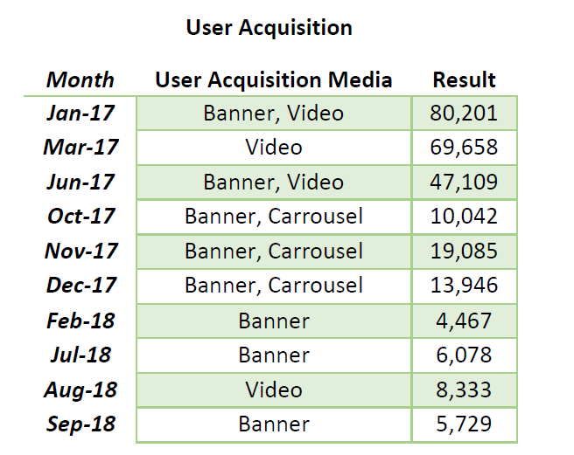

Honestly I didn’t really understand this table. In the study case directions, it is said that User Acquisition comes from the paid user. For example in January 2017, the user acquisition result is 80201. In the table, paying user in January 2017 is 700. I was confused, so I was assuming that the user acquisition table actually list the number of user that converted to try Game X. Based on that notion, let’s see if the media in user acquisition affect the result and if the acquisition result affects other KPI’s such as new user.
From the table there are things that we immediately know. One, in 2018 the media used is reduced. Two, they keep steadily decreasing. Three, the media did have a difference. Media acquisition using Video always net higher numbers compared to the other. So much that, in 2018 where the number is smaller compared to 2017, in August where the media is Video, the number is the highest. I also check wether the month where there is advertising have any spike or not in New User. The result is the ads only made impact in January 2017 (because it’s the launch month), March 2017, and September 2018. It’s still possible raising the number of user using ads, however.
Now after several things about the data is clear, I will proceed to look for the correlations between KPI. Correlations can be calculated easily using Notebook. Basically, correlations is value for each column or feature that affect each other. The highest positive value is 1, means that if a value closer to 1, then both columns affect each other linearly. If one increase, the other also increase. While this is a positive relation, it is possible to have negative value, with -1 is the most negative. Rather than only looking for positive value, it’s also important to look for negative values.
People are more prone to find more positive values than negative. But the truth is, negative correlation value is also affecting each other. The difference is the value is reverse. If one is high, the other is low, so on and so forth. So I will check both negative and positive value. I determine the threshold is about 0.6 and -0.6 for easier reading. It can be changed however, to suit the dataset more. This is the result from checking correlations between the KPI’s from the dataset:

2017 Dataset correlation
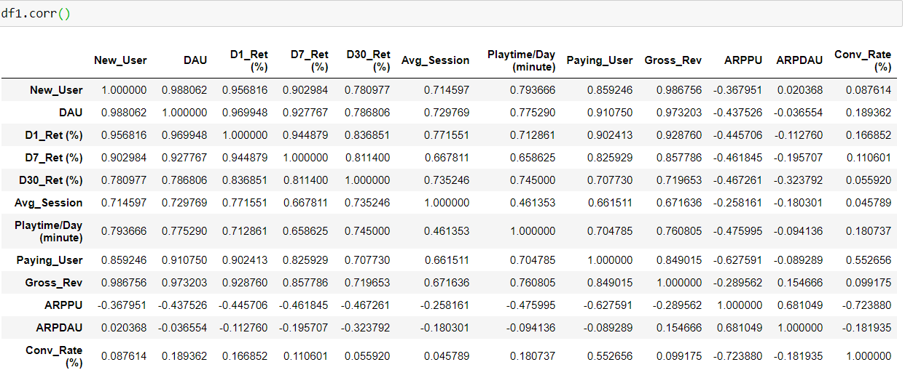
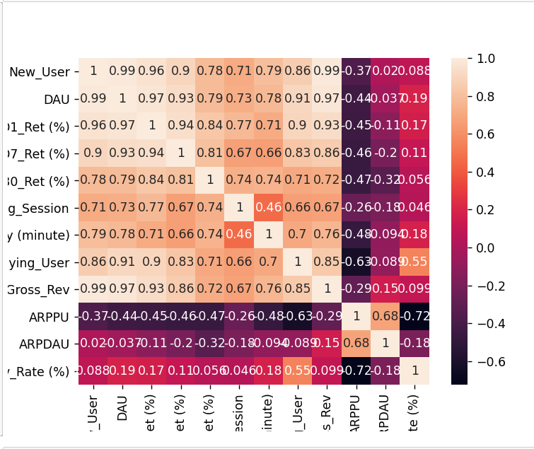
Let’s check the 2017 correlation first. Also, I need to check some columns that apparently not mentioned in the notes. Those columns are DAU, Average Session, Playtime per day, and ARPDAU. Rather than analysis, I feel it’s better for these column to immediately check it’s correlations, especially with the KPI’s we discuss before. It’s possible due to how different the values in both dataset, there will be differences in correlations.
New user seems to have many positive correlations, the exceptions are ARPPU, ARPDAU, and Conversion Rate. Two of them literally important because it specifically mentioned in the notes. Seems like the analysis before is pretty spot on at least in 2017 in that new user isn’t really affecting the ARPPU and Conversion Rate. On the contrary, it did have many positive correlation with Paying User and other columns. It also positively affect the DAU and Gross Revenue, almost perfect, even.
In fact most of the columns have positive correlation with each other (with few only have low correlation value) except ARPPU, ARPDAU, and Conversion Rate (again). They are in the negative and small value correlation with the other column with a few exception. It’s easy if we conclude that the three with lower correlation value can be dismissed, if they are not extremely important and have to be mentioned in the notes. Also, remember that this is just 2017 dataset. To compare it more, let’s check the 2018 dataset correlation.

2018 Dataset correlation

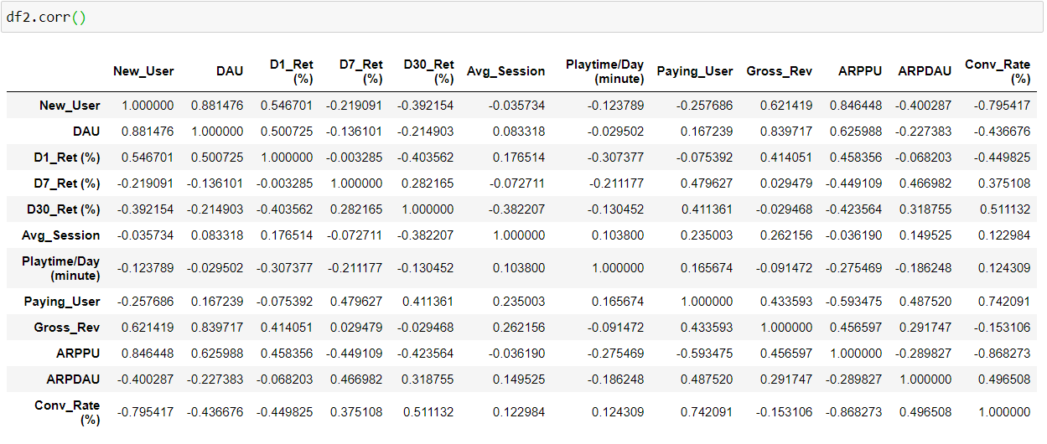

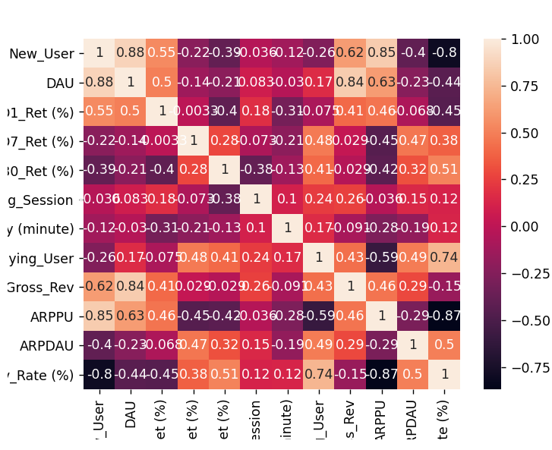

The heatmap actually a lot more colorful now. But now we can finally see what we analyzed before. DAU have high positive corelation with New User is expected. The other column also have different values and colors than the previous dataset. In this dataset, most of the positive correlation from before has been transformed into different value. To compare, let’s see the New User. The correlation between New USer and D30 Retention changed into negative. The correlation between New User and ARPPU decidedly become positive, while with Conversion Rate become far more negative. This is actually inline with what the notes say about ARPPU and Conversion Rate.
For Conversion Rate, it’s negative because how Conversion Rate calculated. While for ARPPU, it’s because probably New User affecting the Gross Revenue based on the correlation heatmap. Much more of this dataset correlations is negative. This is strange, because I though despite the lower value in the column compared to the 2018 dataset, it still very plausible and realistic. I can only conclude that the 2018 really not good for Game X.
Overall I think this dataset is a lot more diverse in it’s correlation. Despite the same column, at a glance the heatmap seems to come from a totally different dataset. This ironically reinforcing the feeling that 2017 and 2018 are completely different year in terms of the game performance. Maybe the hypothesis related to the previous PM resigning was right. I think differences in vision can make the game tread different path, Or even, completely opposite path as intended.
Finally, let’s check the total dataset correlation. I assume that because these 2 dataset really different, when it was joined and calculate the correlation, the result will be not as expected. But of course, I much more positive in that the joined dataset have more surprise.

Total dataset correlation

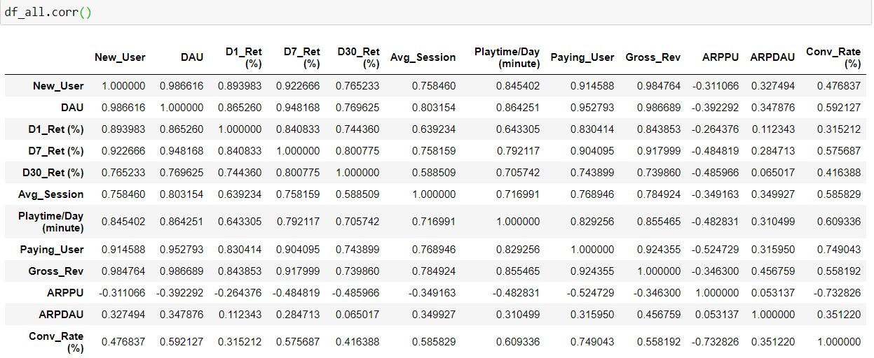

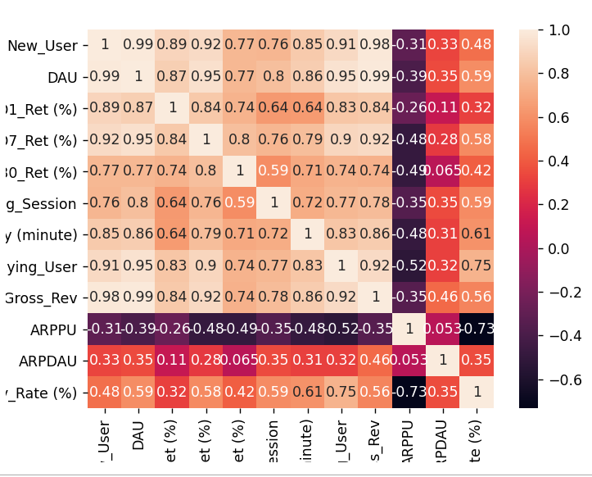

Unsurprisingly the correlation heatmap seems like a fusion between the two previous heatmap. But honestly, I think it’s a lot more chaotic now. In this dataset, the correlation looks almost the same with the 2017 dataset at a glance. Although some value are certainly different now. I suggest for this dataset, rather than relying on the correlations, it’s better to manually analyze it. Like just I do previously.
You can see at least the DAU always have high positive correlation with the new user. Like in the correlations in the 2017 dataset, many columns have positive correlation with the New User. The main difference is now the Conversion Rate, which is important, have more positive correlations. It has more positive correlation with New User, and the Paying User which is quite high. It just that, while as a whole this dataset can be used despite the chaotic correlations, I think if we counted for each year, they are too far apart.
I concluded that right now, these datasets at the state as it is, better not to use it to build model. And I think it’s better to further do some more analysis if these dataset needs to be modelled. Right now, I think the manual analysis that I did before is enough. To end this analysis and preparing answering the questions, I determine several points according to the analysis:

- There is a trend change during transition between 2017 to 2018, as evidenced by lower Funnel step in Tutorial 1 despite no changes in log
- New user by itself never used as a measure how good the game is.
- Splash screen lower funnel maybe affected by the change in advertising and trend
- The user consistently paying is a veteran paid user, while not all new user are converted to paid user
- Paying user consists of veteran player of this game. Also, the new users doesn’t feel engaged enough to pay for the game
- Paying user steadily decreasing overtime despite many new user joining
- To obtain high conversion rate, then the paying user must be high value while the new user at lower value
- Both year actually have similar retention
- For a game to be good (reach 12 $ ARPPU), 1 paying user need to spend at least 12 $.
- To obtain high conversion rate, then the paying user must be high value while the new user at lower value
- By funnel alone, it seems that 2017 version of Game X has greater first impression than the 2018
- Game X from the start is not doing well, not because bad first impression, but Game X staying power is weak
- Probably Game X actually has a strong first impression.
- Not doing well means Game X doesn’t have enough features to keep players playing
- Game X needs more interesting feature compared to now
- The events is not interesting or rewarding enough for the players to keep playing.
- Media acquisition using Video always net higher numbers compared to the other
- As it is, the dataset can’t be immediately turned into models. Some reacquiring the data and more cleaning needed. Also need more opinions from the owner or stakeholders

ANSWERING THE QUESTIONS

- What do you think is 2 most Important KP's that Tim must know to increase Game X Revenue?
Based on the analysis, we know several KP’s important to the Game X as a whole. We also already know from the notes that the KP that show the game is good or not is Conversion Rate and ARPPU. These two seems to be the main metrics for determining a game’s worth. However to increase the revenue, I think the KP’s that needs attention first is Paying User and Gross Revenue.
From previous analysis and notes, it is known that Conversion Rate and ARPPU need Paying User, at least it’s calculations. Make sense. This is tied to the other factor, Gross Revenue. By the calculation of ARPPU, we know that Gross Revenue only come from Paying User. If Game X wanted to increase the revenue, the value of Paying User must be high. Maybe not always paying 12$ per user, but there might be a way to increase the amount of the paying user. All in all, to increase the revenue, Tim needs to find a way to up the number of paying user, and make them keep playing the game if possible.
For Gross Revenue, it’s actually not the KP itself, but the connection it brings. Gross Revenue tied positively in all dataset with New User and DAU, also have positive ties in 2017 and join dataset in all but the three last KP’s. Of course focusing on Gross Revenue alone seems to be very money oriented. But let’s check the facts. Gross revenue is the main income of Game X. It needs to be monitored. If many columns have positive correlation with the Gross Revenue, if they go up, the Gross Revenue should increase. Gross Revenue Increasing means more total revenue for Game X.
Also, I need to explain one important point. While scouring and analyzing the study case, I did not found any single word or sentences that referred to ads, so I assume Game X main income is from Gross Revenue by way of Paying User. While Paying User is very important, relying on them for the only income is not wise in my opinion. Game X is mobile oriented game. That much is true if we see the mechanics, like dungeon or Gacha. Having a little ads like banner in the bottom of the UI is a fair game.

- What do you think is the problem of Game X?
Based on the analysis, I think I found several problem in Game X. The problems for Game X are:
- There are no ads in the game. Say what you want about the game performance, but ads is a form of advertisement. Game X’s only income come from only the Paying User. Game X is not the same genre as Dota 2. Right now Game X main source of income only come from Paying User which declining every month. Do the math.
- Lack or weak features. Game X actually attracts new user, but most of them didn’t stay. Also, not many players played for a long time, probaly because lack of feature or replayability.
- Lack of advertising. This much true, despite new user coming, I still think Game X needs more exposure. If the features already good of course.
- At least in the 2018, too many developments, too little promotions.
- Seems like Game X didn’t understand yet it’s main demographic
- Not much events and things to do apparently. If there are many features, Game X will record a high playing time
- Related to the previous PM resigning, I think Game X lost it’s original vision
- This maybe only my gut feeling, but difference of Funnel in 2017 and 2018 have to do with the game design. Either the design didn’t line with the trend, or the design changed to be less good.

3. What suggestion you will give as data analyst to help Tim increase both Performance and Revenue?
I have several suggestion to Game X related to performance and revenue. They are:
- More interesting features. It’s possible Game X don’t have any staying power or “snare” to wrap the players. We already determined Game X still attract new users yet comparatively fewer paying user. Game X needs feature to be specialized so it can entice more of the players to pay. And that leads to…
- Using the more detailed registration data. Like I said before in the analysis, I did not find any single word or sentences that refer to Target Demographic. Tim need’s to know who the game aims. Is it aimed towards teenagers, kids, or adult? Is it aimed towards specific generations, like millennialas for example?
- Knowing the target demographic will make developing the game more focused and easier. Is it able to attract another demographic outside the main one? Of course, as long as we know the main demographic first. For example, I think most of the MOBA genre is aimed towards boys or men, but character design (like how cute or how handsome a character is) can be the reason for other demograhic to play the game.
- On that note, research the current trend towards game and genre. Game X basically stuck with Dungeon Crawler gacha game, but it can still be tailored towards the trend. For example, robot themed dungeon or new character based on popular sports manga. This needs research of course. Also, connected to this is…
- Increase the variation of the character. I have a personal theory of the East vs West game design. Western games tends to design it’s character with more machoesque figure. Basically vey superheroic. While the eastern tends to design beautiful boys and cute girls. And this is related to detailed registration. Tim could use a specific survey to know the general taste of player. Increasing the variation of the character in Game X is maybe the key to expanding the game. Character variation is not confined in design however. Having many options or class or job for the characters can create various playstyle. It also make the party build a game and meta in on itself, essentially upping the playtime.
- Research why the playtime is amounted to that. Is the dungeon too easy or too short? Or what to do in game if the players not crawling or Gacha-ing? Does the player only spend a little time in the dungeon? These activity needs to be researched and expanded.
- The game needs more source of income beside the paid user. F2P or freemium models sometimes still need ads to stay afloat. I think it’s fair game if Game X contain ads. On that note…
- Game X needs variations for in-game purchases. More items needs to be added. Maybe some premium items. Or if Game X have ads, have an option to buy feature to disable adas (basically a freemium).
- Does the game have active chat and chat room or friend list? I think this is a must feature for mobile game, but, just checking I guess.
- I think the game does not have PVP and ranking system. Connected to the point before, what to do if a player is not crawling or gacha-ing? Fighting other player is one of the ways the developer can provide.
- Related to above, implementation of the rank system. Humans are predilected to numbers and ranks, why not take advantage of that? The rank can be dungeon time, or PVP rank. Humans naturally wanted to stand on the top, use this to prolong the playing time. Maybe needs special item so it also increase the amount of the paying user if they want to be competitive in PVP.
- Increase the mission and dungeon variation. Not only straightforward dungeon, the game can also have puzzle dungeon, or special dungeon that needs specific attribute from the character to beat.
- Maybe revamping the gacha system. The study case didn’t mention it at all, but gacha can be the reason there are fewer returning players. Is it too easy rolling a high level character, or ist too difficult? This needs reasearch but it’s worth the effort.
- Better statistic tracker. This is not only useful for the developer, also player can take advantage of that.
- Better advertisement, and better media used for advertisement. Video is better according to the acquisition table. Don’t advertise like Raid Shadow Legends. Advertise like Hotel Trivago.

